Manner | Abilities | Quantity | Order
Tap | Double Jump | 2 | 1
Trill | Fireball | 3 | 2
Nasal | Divebomb | 7 | 3
Approximative / Lateral Approximative | Wall Jump | 5+4 | 5
Plosive | Explosion | 13 | 4
Fricative / Lateral Fricative | Dash | 22+2 | 6

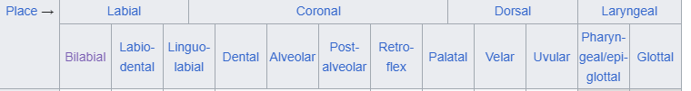

- Plosive: the vocal tract is blocked so that all airflow ceases.
- Nasal: an occlusive consonant produced with a lowered velum (roof of the mouth), allowing air to escape freely through the nose.
- Trill: A trill is made by the articulator being held in place and the airstream causing it to vibrate. Usually a trill vibrates for 2–3 contacts but may be up to 5.
- Tap: produced with a single contraction of the muscles so that one articulator (such as the tongue) is thrown against another.
- Fricative: produced by forcing air through a narrow channel made by placing two articulators close together.
- Approximative: sounds that involve the articulators approaching each other but not narrowly enough nor with enough articulatory precision to create turbulent airflow.

Running through a corridor, killing enemies:
Text1
The International Phonetic Alphabet (IPA) is an alphabetic system of phonetic notation based primarily on the Latin script.
Text2
The IPA is designed to represent those qualities of speech that are part of lexical sounds in oral language: phones, intonation, and the separation of syllables.

Text3
The International Phonetic Association organizes the letters of the IPA into three categories: pulmonic consonants, non-pulmonic consonants, and vowels.

Text4
We don’t talk about non-pulmonic consonants.

Text5
The pulmonic consonant table, which includes most consonants, is arranged in rows that designate manner of articulation, meaning HOW the consonant is produced…

Text6
… and columns that designate place of articulation, meaning WHERE in the vocal tract the consonant is produced.

Text7
This is the IPA Table for pulmonic consonants, stop for a moment and take it in.
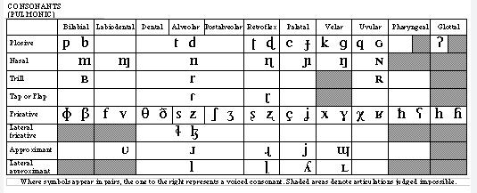

Text8
A pulmonic consonant is a consonant made by obstructing the glottis (the space between the vocal folds) or oral cavity (the mouth) and either simultaneously or subsequently letting out air from the lungs.

Text9
Pulmonic consonant letters are arranged mostly in pairs of voiceless (left) and voiced sounds (right). For instance, P and B are the same consonant. Say it out loud to feel the difference.
Text10
The mouth regions (columns) are placed in the table in the same order they are placed in the mouth:
https://www.happyhourspanish.com/ipa-chart-language-learners/ipa-chart-for-language-learners-sound-placement-mouth/
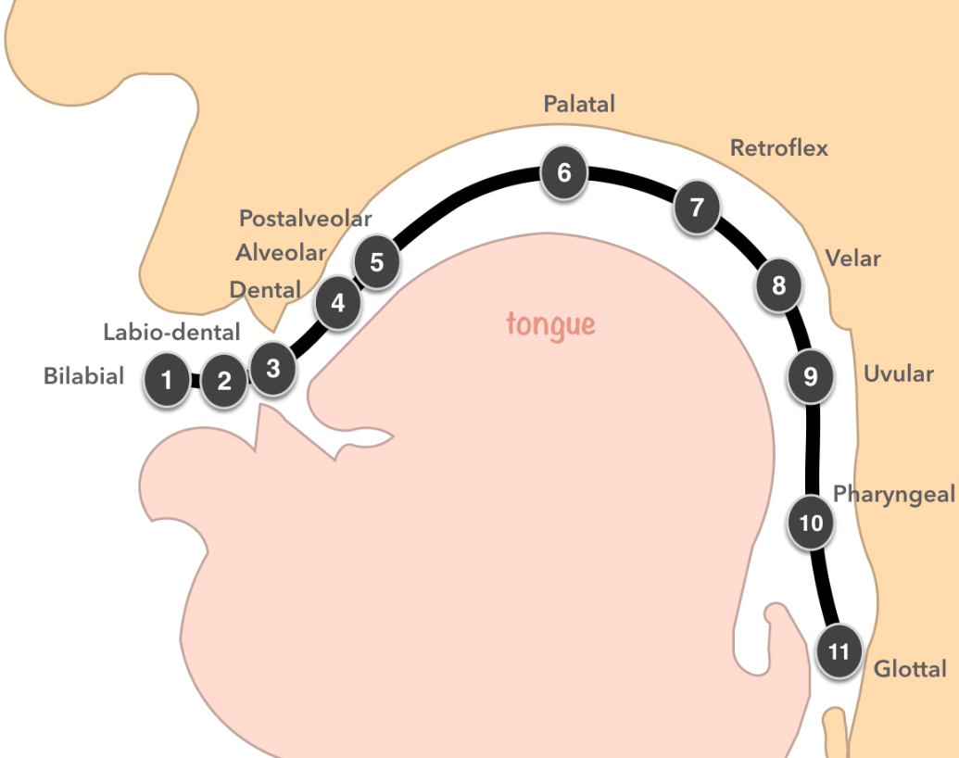

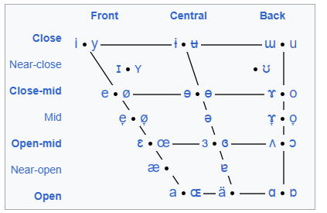
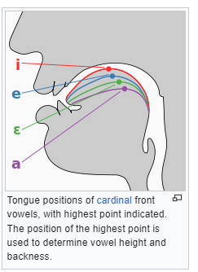
The IPA defines a vowel as a sound which occurs at a syllable center.
The chart maps the vowels according to the position of the tongue.
The vertical axis of the chart is mapped by vowel height. Vowels pronounced with the tongue lowered are at the bottom, and vowels pronounced with the tongue raised are at the top. For example, [ɑ] (the first vowel in father) is at the bottom because the tongue is lowered in this position. [i] (the vowel in "meet") is at the top because the sound is said with the tongue raised to the roof of the mouth.

In a similar fashion, the horizontal axis of the chart is determined by vowel backness. Vowels with the tongue moved towards the front of the mouth (such as [ɛ], the vowel in "met") are to the left in the chart, while those in which it is moved to the back (such as [ʌ], the vowel in "but") are placed to the right in the chart.

In places where vowels are paired, the right represents a rounded vowel (in which the lips are rounded) while the left is its unrounded counterpart.

